Assignment #11 BigQuery Task Google by Joshua Troup

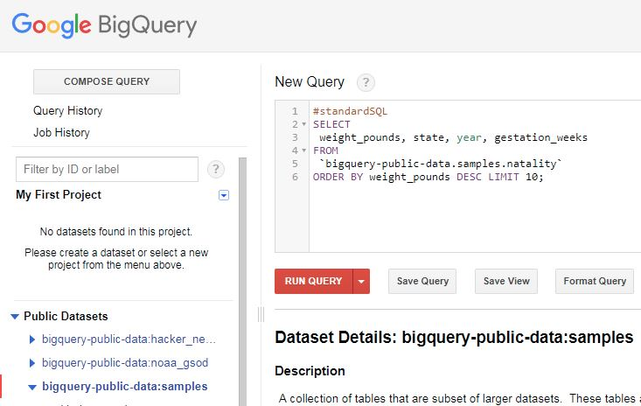

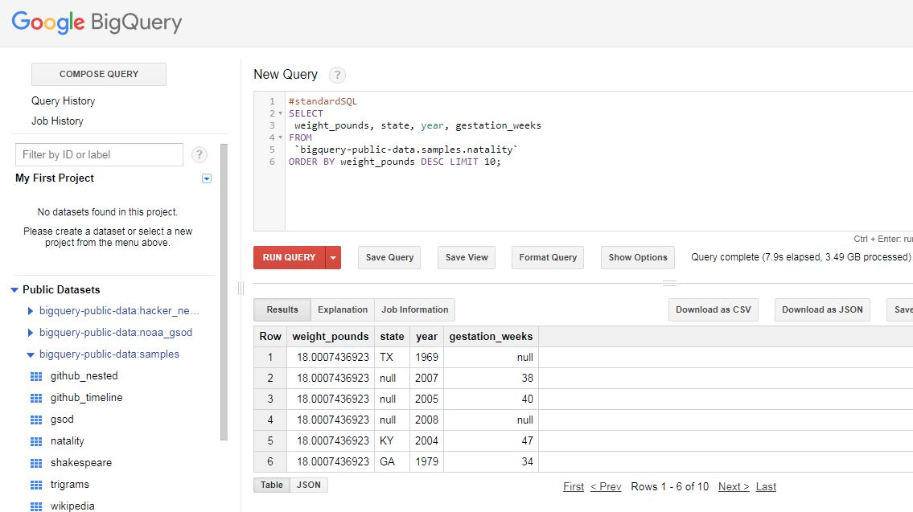

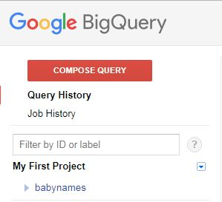

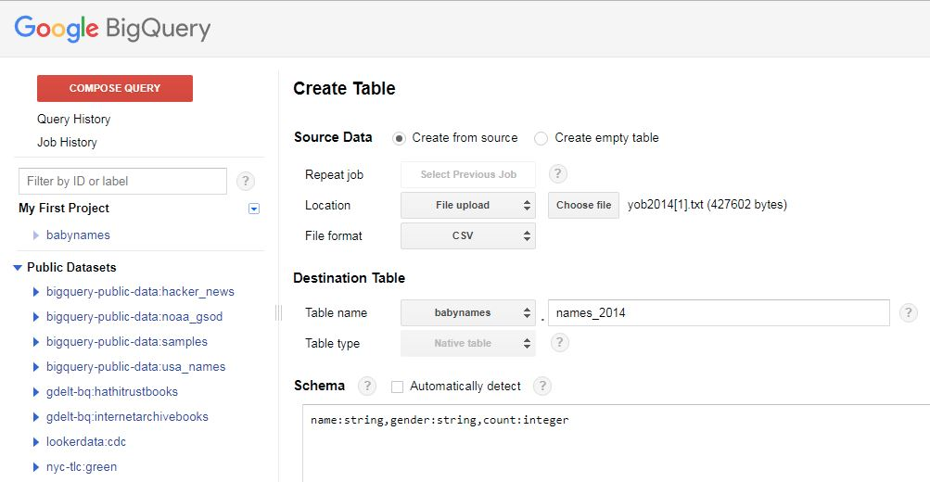

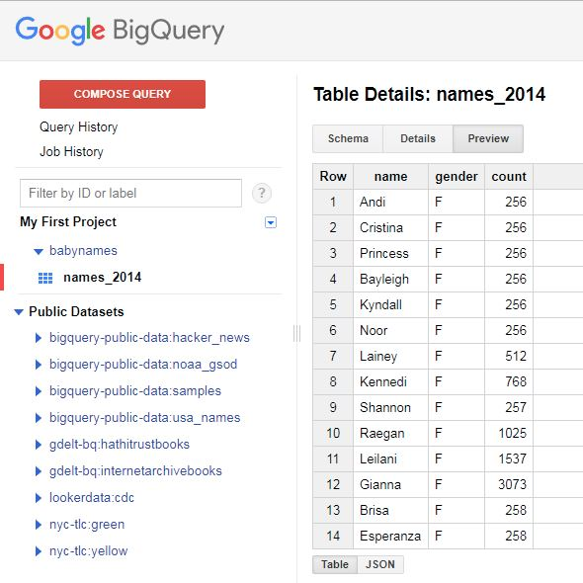

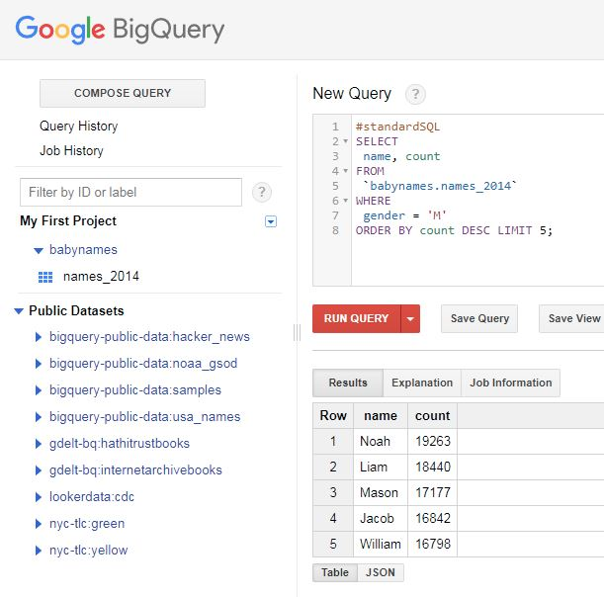

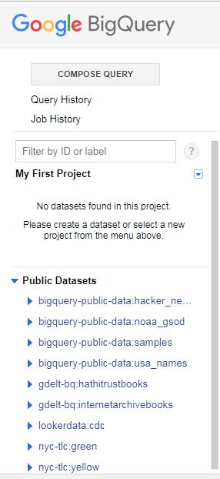

Babynames dataset deleted

Q1: What are the maximum, minimum and average fares for rides lasting 15 minutes or more?

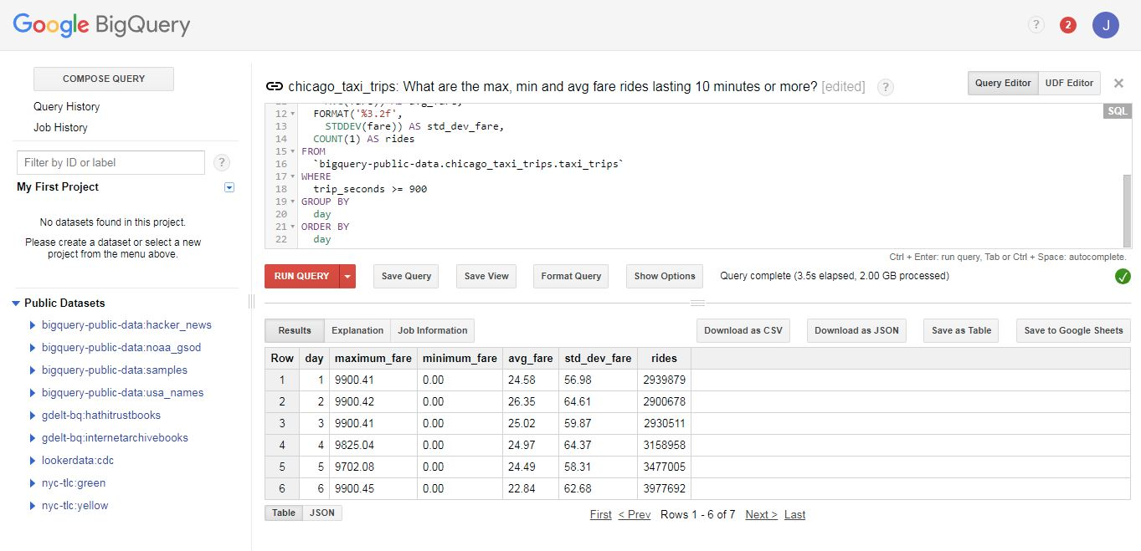

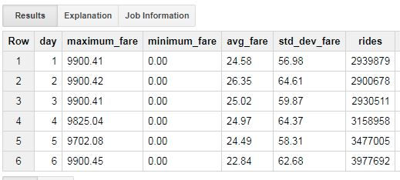

*Follow on critical analysis: Look at the Query results and do you see any outliers in terms of the fares? How do you think this can be addressed?*

Outliers include the maximum fare of $9,900.

Q2. Which drop-off areas have the highest average tip? Limit your results to display only 20 rows.

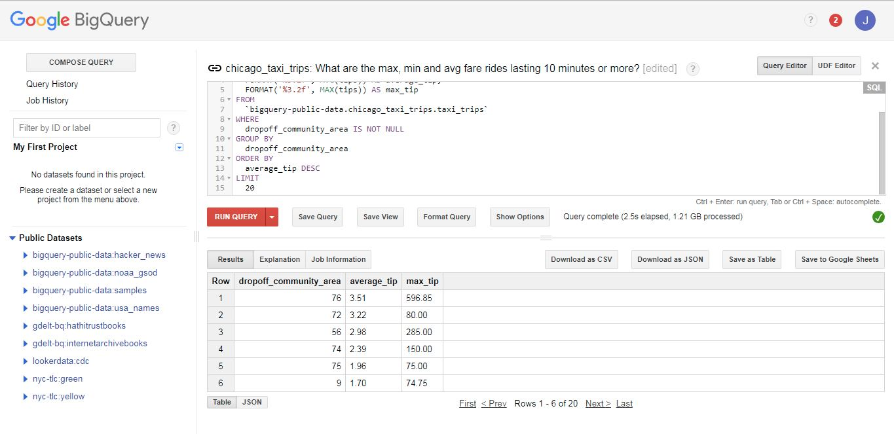

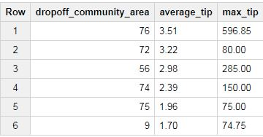

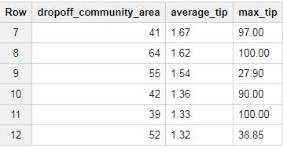

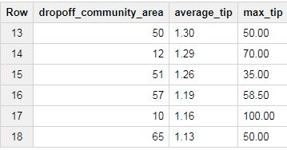

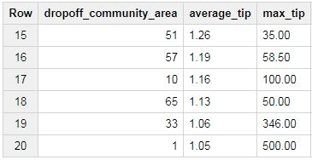

*Follow on critical analysis: Look at community area 76 which happens to be Chicago O’Hare International Airport. What is the highest tips? Is that the highest in the listed 20 results? If yes, why would someone tip a taxi driver such a high $$ amount?*

Highest tip in Chicago O’Hare is $596.85! This is the highest paid tip within the 20 results. There could be many reasons why someone may tip so large. My belief is this person was very successful or worked for a successful company with great generosity.